**Name: - Akhand Pratap Singh**

**Sap ID: - 500085043**

**EXPERIMENT-7**

Title: To understand the concepts of Index.

Q1. Create an index of name EMPLOYEE_IDX on EMPLOYEES with column LAST_NAME, DEPARTMENT_ID.

Code:

--1

CREATE INDEX EMPLOYEE_IDX ON EMPLOYEES (LAST_NAME, DEPARTMENT_ID);

Screenshot:

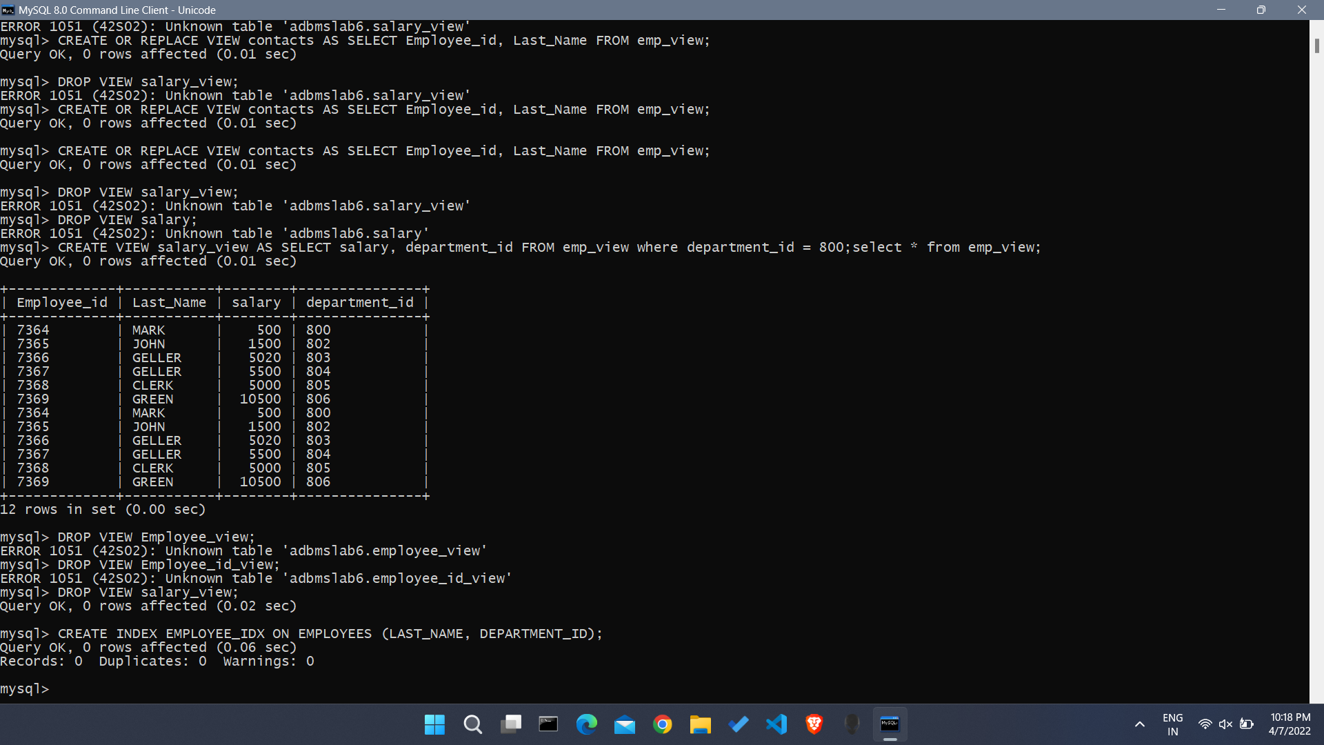

Q2. Find the ROWID for the above table and create a unique index on EMPLOYEE_ID column of the EMPLOYEES.

Code:

--2

SELECT ROW_NUMBER() OVER(ORDER BY DEPARTMENT_ID) AS ID, EMPLOYEE_ID, FIRST_NAME, LAST_NAME, DEPARTMENT_ID FROM EMPLOYEES;

CREATE UNIQUE INDEX EMPLOYEE_UNI_IDX ON EMPLOYEES (EMPLOYEE_ID);

Screenshot:

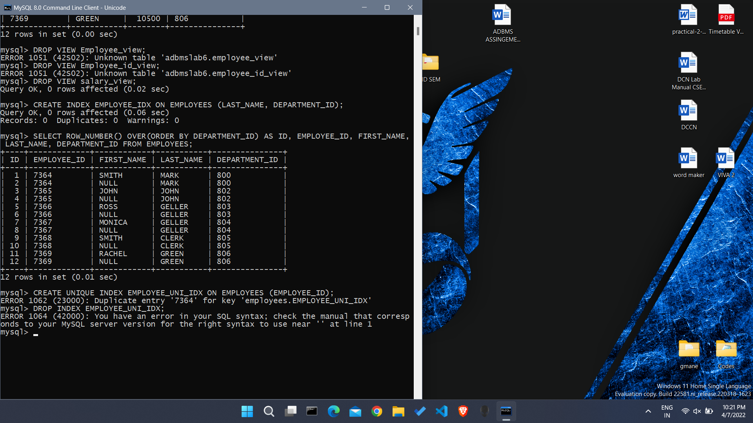

Q3. Create a reverse index on EMPLOYEE_ID column of the EMPLOYEES.

Code:

--3

CREATE INDEX EMP_REVERSE ON EMPLOYEES (EMPLOYEE_ID) REVERSE;

DROP INDEX EMP_REVERSE;

Screenshot:

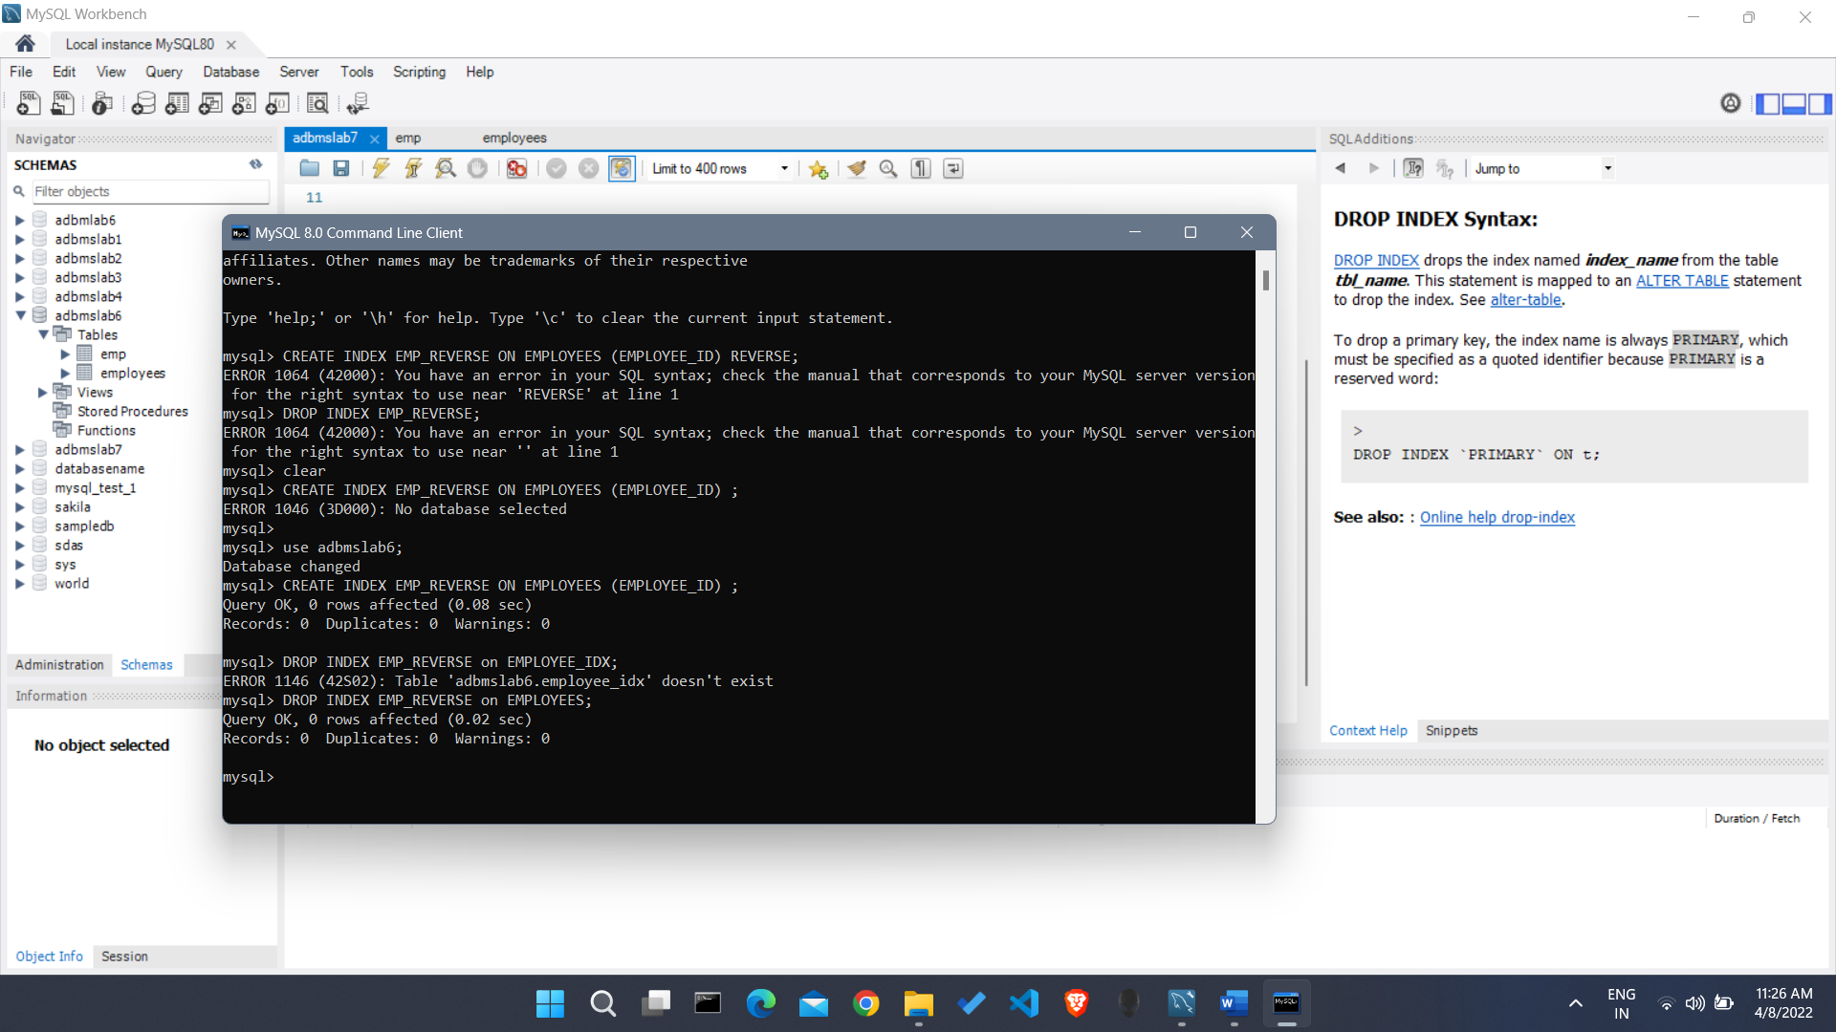

Q4. Create a unique and composite index on EMPLOYEE_ID and check whether there is duplicity of tuples or not.

Code:

--4

CREATE UNIQUE INDEX EMPLOYEE_UNI_COMP ON EMPLOYEES (EMPLOYEE_ID, DEPARTMENT_ID);

SELECT * FROM EMPLOYEES WHERE EMPLOYEE_ID = '7365' AND DEPARTMENT_ID = ' 802';

Screenshot:

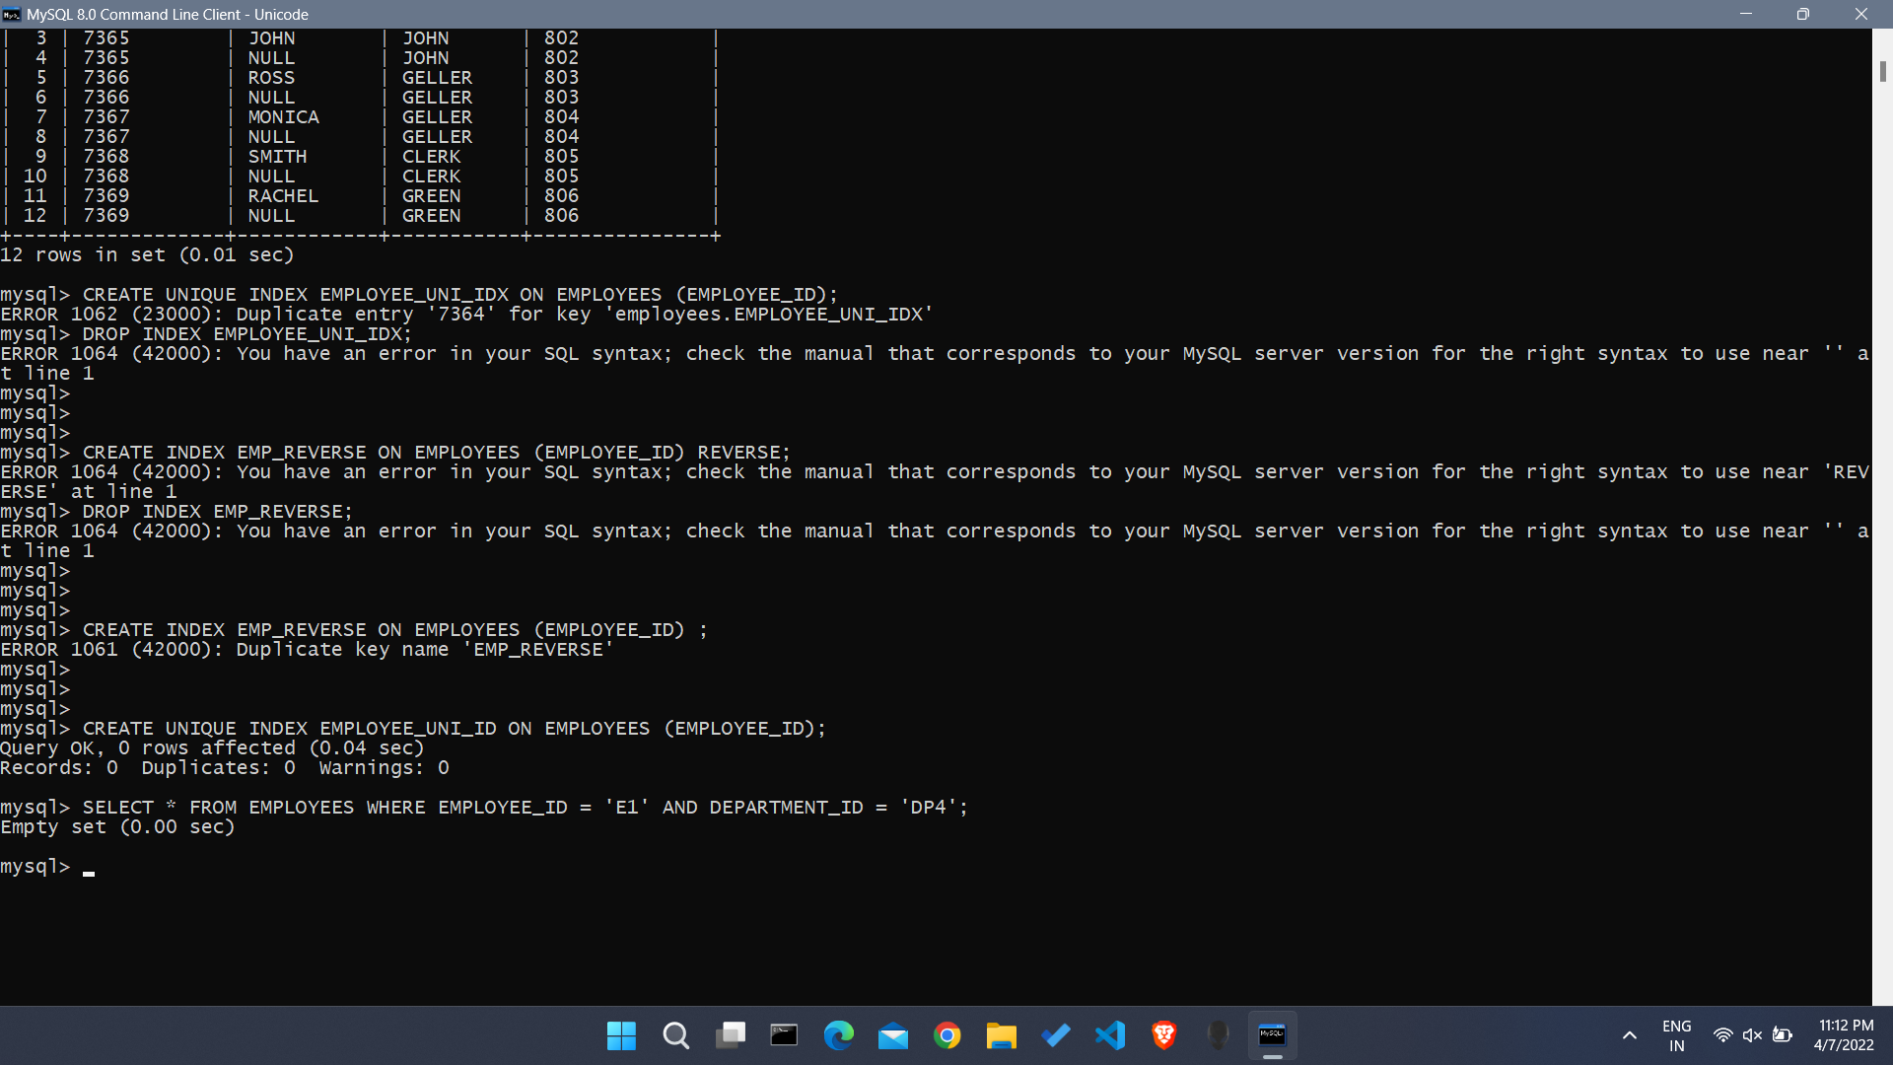

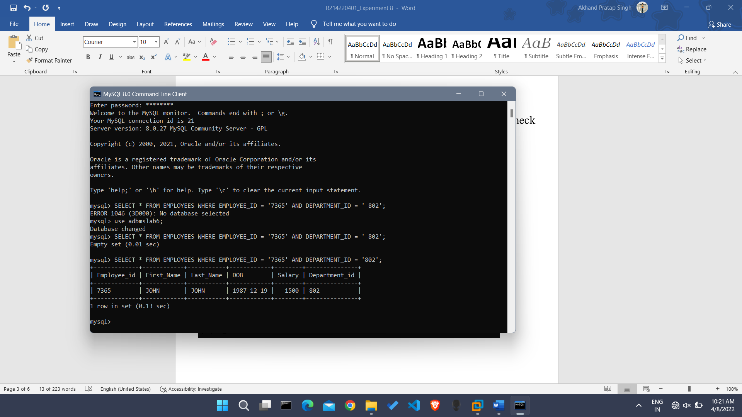

Q5. Create Function-based indexes defined on the SQL functions UPPER(column_name) or LOWER(column_name) to facilitate case-insensitive searches on column LAST_NAME.

Code:

--5

CREATE INDEX LAST_NAME_IDX ON EMPLOYEES (UPPER(LAST_NAME));

CREATE INDEX LAST_NAME_IDX2 ON EMPLOYEES (lower (LAST_NAME));

Screenshot:

Q6. Drop the function-based index on column LAST_NAME.

Code:

--6

DROP INDEX LAST_NAME_IDX;

DROP INDEX LAST_NAME_IDX2;

Screenshot: